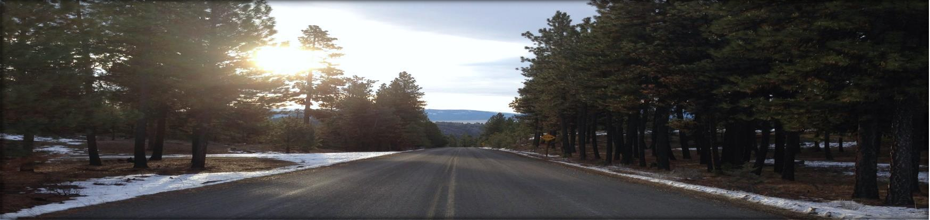
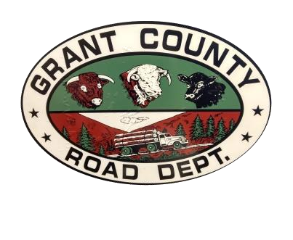

NOTICE OF 2025 CHIP SEAL PROJECT

GRANT COUNTY ROAD DEPARTMENT

County Road 65, Canyon Creek Lane

The Grant County Road Department will begin its chip seal season on
Monday, June 23rd and continue through June 26.
We will be crack sealing @ 8 miles of County Road #65 (Canyon Creek Lane) .
Work schedule is Monday – Thursday, 6 am-5:00 pm.
Travel with caution through the work zone and
be prepared for fresh oil and delays.
There will be traffic control devices and pilot cars.
For further information on this project call the
Road Department at 541-575-0138.

GRANT COUNTY ROAD DEPARTMENT
27941 Lower Yard Road John Day, OR 97845
Alan Hickerson, Road Master 541-575-3783
hickersona@grantcounty-or.gov
Tammy Workman, Office Manager 541-575-3781
tworkman@grantcounty-or.gov

